Tab 1
CPS 510 - Section 04
Prof: A. Abhari
TA: W. Shabana

Hotel Management Database Management System

Group 1

Members
Sakib Chowdhury - Student #: 501112572
Nithan Brindamohan - Student #: 501223704

Table Of Contents

Table Of Contents 1
Assignment 1 3
Assignment 2 13
Assignment 3 14
Table Creation Script 15
Populate Tables Script 19
Simple Queries 21
Assignment 4 22
Part 1 22
Part 2 25
Views 25
Queries 28
Advanced Join Queries (similar to Q9 & Q10) 32
Assignment 5 34
Queries like Q11 - Q23 34
Assignment 6 - 8 38
Assignment 6 38
PREVIOUS Tables & Keys & Dependencies Before Changes 38
Assignment 7 44
UPDATED Tables & Keys & IDENTIFIED Transitive Dependencies 44
Assignment 8 46
FINAL Tables & Keys & Dependencies 46
BCNF Verification 50
Assignment 9 52
Compilation & Menu 52
Create Tables 53
Create Views 54
Populate Tables 54
Advanced Queries Menu 55
Advanced Query Example 55
Back to Main Menu 56
Search Menu 56
Search Example 56
Drop Views 57
Drop Tables 58
Exit 58

Assignment 1
Assignment 1: Week of Sep. 8
Application Description: Finalize the application in consultation with the lab TA. Prepare a report to clearly describe about the application, its functions and information you expect from it, at the level of a technical report, and submit it to the TA (6 Marks)
Overview
The chosen project topic is Hotel Management System. It will be designed to handle the daily operations of a hotel, providing functionality for handling rooms, employees, guests, bookings, additional services and keeping track of payments. Additionally, it will have functionality for enforcing business rules through constraints to ensure data consistency and good structure. For example, to avoid duplicating Customer records, it will restrict the creation of Customers that have identical contact information.
The report is broken into 6 sections:
- Overview: The current section, a brief introduction to the report.
- Entities: This section will expand on the core entities for the DB.
- Relationships: This section will go over the various relationships between the previously mentioned entities.
- Constraints: This section will go over constraint/business rules for how data will be recorded.
- Potential Operations: A list of potential query and update operations that may be performed.
- Potential Users & Interface Requirements: This will cover the potential types of users of the system and what kind of interface they may require.
Entities

ROOM_TYPE
RoomTypeID | RoomTypeName | MaxCapacity

ROOM
RoomID | RoomNum | Floor | RoomType | Price | Status

CUSTOMER
CustomerID | CusName | PhoneNum | Email | IDType

EMPLOYEE
EmployeeID | EmpName | EmpRole | PhoneNum | Email | Salary

BOOKING
BookingID | EmployeeID | NumGuests | CheckIn | CheckOut | Status | TotalPrice

BOOKING_CUSTOMER
BookingID | CustomerID

BOOKING_ROOM
BookingID | RoomID

PAYMENT
PaymentID | BookingID | Method | PaymentDate | Amount

SERVICE
ServiceID | ServiceName | Price

SERVICE_BOOKING
ServiceBookingID | BookingID | ServiceID | Quantity

Relationships

ROOM_TYPE - ROOM
- Every ROOM must belong to one ROOM_TYPE
- A ROOM_TYPE can be associated with many ROOMs

EMPLOYEE - BOOKING
- One EMPLOYEE can be associated with many BOOKINGs
- Each BOOKING is associated with one EMPLOYEE

BOOKING - ROOM
- A BOOKING may involve multiple ROOMs
- A ROOM may appear in multiple BOOKINGs (over time)

BOOKING - CUSTOMER
- A BOOKING can include one or more CUSTOMERs
- A CUSTOMER can have many BOOKINGs

BOOKING - PAYMENT
- Each BOOKING can have only one PAYMENT record
- A PAYMENT must be linked to exactly one BOOKING

SERVICE — BOOKING via SERVICE_BOOKING
- A Booking may include multiple Services
- A Service may be used across many Bookings

Constraints
General Constraints
- The initial ID column of each table must be unique. (PK)

ROOM_TYPE Constraints
- Primary key
  - PK_ROOM_TYPE PRIMARY KEY (ROOMTYPEID)
- NOT NULL columns
  - ROOMTYPEID NOT NULL
  - ROOMTYPENAME NOT NULL
  - MAXCAPACITY NOT NULL

ROOM Constraints
- Primary key
  - RoomID NUMBER PRIMARY KEY
- NOT NULL columns
  - RoomNum NOT NULL
  - Floor NOT NULL
  - RoomType NOT NULL
  - Price NOT NULL
  - Status NOT NULL
- Uniqueness
  - RoomNum UNIQUE
- Foreign keys
  - FK_ROOM_ROOMTYPE FOREIGN KEY (RoomType) REFERENCES ROOM_TYPE(ROOMTYPEID)
- Check constraints
  - chk_floor_nonnegative → Floor >= 1
  - chk_price_nonnegative → Price >= 0
  - chk_status → Status must be one of: 'Available','Unavailable','Maintenance'

CUSTOMER Constraints
- Primary key
  - CustomerID NUMBER PRIMARY KEY
- NOT NULL columns
  - CusName NOT NULL
  - PhoneNum NOT NULL
  - Email NOT NULL
  - IDType NOT NULL
- Uniqueness
  - PhoneNum UNIQUE
  - Email UNIQUE
  - uq_customer_phone_email UNIQUE (PhoneNum, Email)
- Check constraints
  - chk_idtype → IDType must be one of: 'Passport', 'DriverLicense', 'NationalID', 'Other'
  - chk_phone_digits → PhoneNum must match regex '^[0-9]+$' (digits only)
  - chk_email_format → Email must match email regex pattern

EMPLOYEE constraints
- Primary key
  - EmployeeID NUMBER PRIMARY KEY
- NOT NULL columns
  - EmpName NOT NULL
  - EmpRole NOT NULL
  - PhoneNum NOT NULL
  - Email NOT NULL
  - Salary NUMBER(10,2) NOT NULL
- Uniqueness
  - PhoneNum UNIQUE
  - Email UNIQUE
  - uq_emp_phone_email UNIQUE (PhoneNum, Email)
- Check constraints
  - chk_emp_role → EmpRole must be one of:
    - 'Receptionist','Housekeeper','Cook','Manager','Owner'
  - chk_emp_salary_nonnegative → Salary >= 0
  - chk_emp_phone_digits → PhoneNum must be digits only ('^[0-9]+$')
  - chk_emp_email_format → Email must match email regex pattern

BOOKING Constraints
- Primary key
  - BookingID NUMBER PRIMARY KEY
- NOT NULL columns
  - EmployeeID NOT NULL
  - NumGuests NOT NULL
  - CheckIn NOT NULL
  - CheckOut NOT NULL
  - Status NOT NULL
  - TotalPrice NOT NULL
- Foreign keys
  - fk_booking_emp FOREIGN KEY (EmployeeID) REFERENCES Employee(EmployeeID)
- Check constraints
  - chk_booking_guests → NumGuests >= 1
  - chk_booking_dates → CheckIn < CheckOut
  - chk_booking_status → Status must be one of:
    - 'Pending','Confirmed','Checkedin','Completed','Cancelled'
  - chk_booking_total_nonneg → TotalPrice >= 0
BOOKING_ROOM Constraints
- Primary key (composite)
  - PRIMARY KEY (BookingID, RoomID)
- NOT NULL columns
  - BookingID NOT NULL
  - RoomID NOT NULL
- Foreign keys
  - fk_br_booking FOREIGN KEY (BookingID) REFERENCES Booking(BookingID) ON DELETE CASCADE
  - fk_br_room FOREIGN KEY (RoomID) REFERENCES Room(RoomID) ON DELETE CASCADE
BOOKING_CUSTOMER Constraints
- Primary key (composite)
  - PRIMARY KEY (BookingID, CustomerID)
- NOT NULL columns
  - BookingID NOT NULL
  - CustomerID NOT NULL
- Foreign keys
  - fk_bc_booking FOREIGN KEY (BookingID) REFERENCES Booking(BookingID) ON DELETE CASCADE
  - fk_bc_customer FOREIGN KEY (CustomerID) REFERENCES Customer(CustomerID) ON DELETE CASCADE

PAYMENT Constraints
- Primary key
  - PaymentID NUMBER PRIMARY KEY
- NOT NULL columns
  - BookingID NOT NULL
  - Method NOT NULL
  - PaymentDate NOT NULL
  - Amount NOT NULL
- Uniqueness
  - BookingID UNIQUE → at most one payment per booking
- Foreign keys
  - fk_payment_booking FOREIGN KEY (BookingID) REFERENCES Booking(BookingID) ON DELETE CASCADE
- Check constraints
  - chk_payment_method → Method must be one of: 'Cash','Credit','Debit'
  - chk_payment_amt → Amount >= 0

SERVICE Constraints
- Primary key
  - ServiceID NUMBER PRIMARY KEY
- NOT NULL columns
  - ServiceName NOT NULL
  - Price NOT NULL
- Uniqueness
  - ServiceName UNIQUE
- Check constraints
  - chk_service_price_nonnegative → Price >= 0

SERVICE_BOOKING Constraints
- Primary key (composite)
  - PRIMARY KEY (BookingID, ServiceID)
- NOT NULL columns
  - BookingID NOT NULL
  - ServiceID NOT NULL
  - Quantity NOT NULL
- Foreign keys
  - fk_sb_booking FOREIGN KEY (BookingID) REFERENCES Booking(BookingID) ON DELETE CASCADE
  - fk_sb_service FOREIGN KEY (ServiceID) REFERENCES Service(ServiceID) ON DELETE CASCADE
- Check constraints
  - chk_sb_qty → Quantity >= 1

Potential Operations
Queries:
- List the names of all guests currently staying on Floor 2 of the hotel
- List all employee salaries
- Obtain the room number of a guest with the name “John Doe”
Update:
- After a guest has checked in, update the Status of their booking to “CheckedIn”.
- After a guest has checked out, update the Status of their booking to “Completed”.
- Change the Status of a room to “Maintenance” if it is undergoing maintenance and is thus unavailable.
Potential Users and Interface Requirements
Customer / Guest
- Tasks:
  - Search for available rooms
    - Limit results with filters selected by the guest
  - Make a booking
  - Add extra services not their booking
  - View booking history and invoices
- Interface Requirements:
  - Forms to select filters when searching for rooms, or booking history
  - Tables to show results
  - Payment Portal
Receptionists
- Tasks / Applications:
  - Check room availability
  - Create new bookings for walk-in customers
  - Update booking status (check-in, check-out, cancellation, no-show)
  - Record payments (cash, card, debit)
  - Assign services (e.g., room service, laundry)
- Interface:
  - Desktop application or web dashboard with:
    - Room availability view (calendar-style)
    - Booking management form
    - Payment entry form
Housekeepers
- Tasks / Applications:
  - Update room status (Available, Occupied, Cleaning, Maintenance).
  - Report issues with a room (broken equipment, cleaning required).
- Interface:
  - Simple mobile/tablet interface with:
  - Room list (with status filters).
  - Quick update buttons for changing Room Status
Manager
- Tasks / Applications:
  - Manage employees (roles, salaries).
  - Monitor all available rooms and booking histories.
  - Adjust room rates and service prices.
  - Create reports using data from previous bookings
- Interface:
  - Management dashboard with more information than Receptionists
  - Forms to update prices, manage employees, adjust services.
Owner
- Same as Manager

Assignment 2
Assignment 2: Week of Sept 15
ER model: Prepare the ER model (12 Marks)
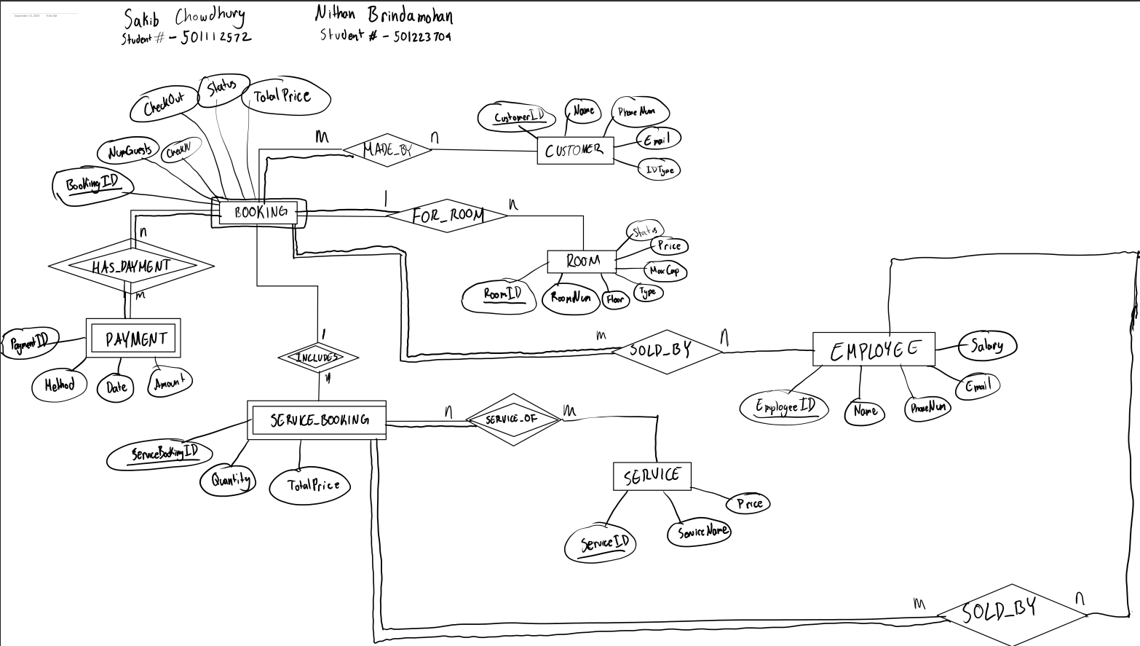

Assignment 3
Assignment 3: Week of Sep 22 (6 Marks)
Schema design: Use Oracle to create the tables derived from ER/EER diagram as discussed in the class and submit the source code.
Database construction: Populate the tables of the database and create simple queries: use SQL- Oracle as discussed in the class and follow the examples of lecture notes topic 5 (SQL) create and insert statements.

Table Creation Script
CREATE TABLE ROOM_TYPE (
ROOMTYPEID NUMBER NOT NULL,
ROOMTYPENAME VARCHAR2(20) NOT NULL,
MAXCAPACITY NUMBER NOT NULL,
CONSTRAINT PK_ROOM_TYPE PRIMARY KEY (ROOMTYPEID)
)

CREATE TABLE Room(
RoomID NUMBER PRIMARY KEY,
RoomNum NUMBER NOT NULL UNIQUE,
Floor NUMBER NOT NULL,
RoomType NUMBER NOT NULL,
Price NUMBER(10,2) NOT NULL,
Status VARCHAR2(20) NOT NULL,

CONSTRAINT chk_floor_nonnegative CHECK (Floor >= 1),
CONSTRAINT chk_price_nonnegative CHECK (Price >= 0),
CONSTRAINT chk_status CHECK (Status IN ('Available', 'Unavailable', 'Maintenance')),
CONSTRAINT FK_ROOM_ROOMTYPE FOREIGN KEY (RoomType) REFERENCES ROOM_TYPE(ROOMTYPEID)
)

CREATE TABLE Customer(
CustomerID NUMBER PRIMARY KEY,
CusName VARCHAR2(100) NOT NULL,
PhoneNum VARCHAR2(20) NOT NULL UNIQUE,
Email VARCHAR2(254) NOT NULL UNIQUE,
IDType VARCHAR2(20) NOT NULL,

CONSTRAINT uq_customer_phone_email UNIQUE (PhoneNum, Email),
CONSTRAINT chk_idtype CHECK (IDType IN ('Passport', 'DriverLicense', 'NationalID', 'Other')),
CONSTRAINT chk_phone_digits CHECK (REGEXP_LIKE(PhoneNum, '^[0-9]+$')),
CONSTRAINT chk_email_format CHECK (REGEXP_LIKE(Email, '^[A-Za-z0-9._%+-]+@[A-Za-z0-9.-]+\\.[A-Za-z]{2,}$'))
)

CREATE TABLE Employee (
EmployeeID NUMBER PRIMARY KEY,
EmpName VARCHAR2(100) NOT NULL,
EmpRole VARCHAR2(30) NOT NULL,
PhoneNum VARCHAR2(20) NOT NULL UNIQUE,
Email VARCHAR2(254) NOT NULL UNIQUE,
Salary NUMBER(10,2) NOT NULL,

CONSTRAINT uq_emp_phone_email UNIQUE (PhoneNum, Email),
CONSTRAINT chk_emp_role CHECK (EmpRole IN ('Receptionist','Housekeeper','Cook','Manager','Owner')),
CONSTRAINT chk_emp_salary_nonnegative CHECK (Salary >= 0),
CONSTRAINT chk_emp_phone_digits CHECK (REGEXP_LIKE(PhoneNum, '^[0-9]+$')),
CONSTRAINT chk_emp_email_format CHECK (REGEXP_LIKE(Email, '^[A-Za-z0-9._%+-]+@[A-Za-z0-9.-]+\\.[A-Za-z]{2,}$'))
)

CREATE TABLE Service (
ServiceID NUMBER PRIMARY KEY,
ServiceName VARCHAR2(100) NOT NULL UNIQUE,
Price NUMBER(10,2) NOT NULL,

CONSTRAINT chk_service_price_nonnegative CHECK (Price >= 0)
)

CREATE TABLE Booking (
BookingID NUMBER PRIMARY KEY,
EmployeeID NUMBER NOT NULL,
NumGuests NUMBER NOT NULL,
CheckIn DATE NOT NULL,
CheckOut DATE NOT NULL,
Status VARCHAR2(20) NOT NULL,
TotalPrice NUMBER(10,2) NOT NULL,

CONSTRAINT fk_booking_emp FOREIGN KEY (EmployeeID) REFERENCES Employee(EmployeeID),
CONSTRAINT chk_booking_guests CHECK (NumGuests >= 1),
CONSTRAINT chk_booking_dates CHECK (CheckIn < CheckOut),
CONSTRAINT chk_booking_status CHECK (Status IN ('Pending','Confirmed','Checkedin','Completed','Cancelled')),
CONSTRAINT chk_booking_total_nonneg CHECK (TotalPrice >= 0)
)

CREATE TABLE Booking_Room (
BookingID NUMBER NOT NULL,
RoomID NUMBER NOT NULL,
PRIMARY KEY (BookingID, RoomID),

CONSTRAINT fk_br_booking FOREIGN KEY (BookingID) REFERENCES Booking(BookingID) ON DELETE CASCADE,
CONSTRAINT fk_br_room FOREIGN KEY (RoomID) REFERENCES Room(RoomID) ON DELETE CASCADE
)

CREATE TABLE Booking_Customer (
BookingID NUMBER NOT NULL,
CustomerID NUMBER NOT NULL,
PRIMARY KEY (BookingID, CustomerID),

CONSTRAINT fk_bc_booking FOREIGN KEY (BookingID) REFERENCES Booking(BookingID) ON DELETE CASCADE,
CONSTRAINT fk_bc_customer FOREIGN KEY (CustomerID) REFERENCES Customer(CustomerID) ON DELETE CASCADE
)

CREATE TABLE Payment (
PaymentID NUMBER PRIMARY KEY,
BookingID NUMBER NOT NULL UNIQUE,
Method VARCHAR2(10) NOT NULL,
PaymentDate DATE NOT NULL,
Amount NUMBER(10,2) NOT NULL,

CONSTRAINT fk_payment_booking FOREIGN KEY (BookingID) REFERENCES Booking(BookingID) ON DELETE CASCADE,
CONSTRAINT chk_payment_method CHECK (Method IN ('Cash','Credit','Debit')),
CONSTRAINT chk_payment_amt CHECK (Amount >= 0)
)

CREATE TABLE Service_Booking (
BookingID NUMBER NOT NULL,
ServiceID NUMBER NOT NULL,
Quantity NUMBER NOT NULL,
PRIMARY KEY (BookingID, ServiceID),

CONSTRAINT fk_sb_booking FOREIGN KEY (BookingID) REFERENCES Booking(BookingID) ON DELETE CASCADE,
CONSTRAINT fk_sb_service FOREIGN KEY (ServiceID) REFERENCES Service(ServiceID) ON DELETE CASCADE,
CONSTRAINT chk_sb_qty CHECK (Quantity >= 1)
)

Populate Tables Script
ROOM_TYPE
INSERT INTO ROOM_TYPE VALUES (1, 'Single', 1);
INSERT INTO ROOM_TYPE VALUES (2, 'Double', 2);
INSERT INTO ROOM_TYPE VALUES (3, 'Family', 4);

ROOM
INSERT INTO Room (RoomID, RoomNum, Floor, RoomType, Price, Status) VALUES (1, 101, 1, 1, 120.00, 'Available');
INSERT INTO Room (RoomID, RoomNum, Floor, RoomType, Price, Status)
VALUES (2, 102, 1, 2, 180.00, 'Available');
INSERT INTO Room (RoomID, RoomNum, Floor, RoomType, Price, Status)
VALUES (3, 201, 2, 3, 300.00, 'Unavailable');
INSERT INTO Room (RoomID, RoomNum, Floor, RoomType, Price, Status) VALUES (4, 202, 2, 1, 110.00, 'Maintenance');
INSERT INTO Room (RoomID, RoomNum, Floor, RoomType, Price, Status)
VALUES (5, 301, 3, 2, 200.00, 'Available');

CUSTOMER
INSERT INTO Customer (CustomerID, CusName, PhoneNum, Email, IDType)
VALUES (1, 'John Smith', '4161234567', 'john.smith@example.com', 'Passport');
INSERT INTO Customer (CustomerID, CusName, PhoneNum, Email, IDType) VALUES (2, 'Maria Gonzalez', '6479876543', 'maria.gonzalez@example.com', 'DriverLicense');
INSERT INTO Customer (CustomerID, CusName, PhoneNum, Email, IDType) VALUES (3, 'David Chen', '4375551122', 'david.chen@example.com', 'NationalID');
INSERT INTO Customer (CustomerID, CusName, PhoneNum, Email, IDType) VALUES (4, 'Aisha Khan', '2893217788', 'aisha.khan@example.com', 'Other');

EMPLOYEE
INSERT INTO Employee (EmployeeID, EmpName, EmpRole, PhoneNum, Email, Salary) VALUES (1, 'Alice Johnson', 'Receptionist', '4165551001', 'alice.johnson@example.com', 42000.00);
INSERT INTO Employee (EmployeeID, EmpName, EmpRole, PhoneNum, Email, Salary) VALUES (2, 'Brian Lee', 'Housekeeper', '4165551002', 'brian.lee@example.com', 35000.00);
INSERT INTO Employee (EmployeeID, EmpName, EmpRole, PhoneNum, Email, Salary) VALUES (3, 'Carlos Rivera', 'Cook', '4165551003', 'carlos.rivera@example.com', 38000.00);
INSERT INTO Employee (EmployeeID, EmpName, EmpRole, PhoneNum, Email, Salary) VALUES (4, 'Diana Patel', 'Manager', '4165551004', 'diana.patel@example.com', 60000.00);
INSERT INTO Employee (EmployeeID, EmpName, EmpRole, PhoneNum, Email, Salary) VALUES (5, 'Edward Brown', 'Owner', '4165551005', 'edward.brown@example.com', 80000.00);

SERVICE
INSERT INTO Service (ServiceID, ServiceName, Price) VALUES (1, 'Breakfast Buffet', 20.00);
INSERT INTO Service (ServiceID, ServiceName, Price) VALUES (2, 'Airport Shuttle', 45.00);
INSERT INTO Service (ServiceID, ServiceName, Price) VALUES (3, 'Laundry Service', 15.00);
INSERT INTO Service (ServiceID, ServiceName, Price) VALUES (4, 'Spa Package', 100.00);
INSERT INTO Service (ServiceID, ServiceName, Price) VALUES (5, 'Extra Bed', 30.00);

BOOKING (example: BOOKING 1001 + RELATIONS)
INSERT INTO Booking (BookingID, EmployeeID, NumGuests, CheckIn, CheckOut, Status, TotalPrice) VALUES (1001, 1, 3, DATE '2025-10-01', DATE '2025-10-05', 'Confirmed', 1075.00);
INSERT INTO Booking_Room (BookingID, RoomID) VALUES (1001, 2);
INSERT INTO Booking_Room (BookingID, RoomID) VALUES (1001, 5);
INSERT INTO Booking_Customer (BookingID, CustomerID) VALUES (1001, 1);
INSERT INTO Booking_Customer (BookingID, CustomerID) VALUES (1001, 2);
INSERT INTO Payment (PaymentID, BookingID, Method, PaymentDate, Amount) VALUES (5001, 1001, 'Credit', DATE '2025-09-20', 1075.00);

BOOKING (example: BOOKING 1002 + RELATIONS)
INSERT INTO Booking (BookingID, EmployeeID, NumGuests, CheckIn, CheckOut, Status, TotalPrice) VALUES (1002, 4, 1, DATE '2025-11-10', DATE '2025-11-12', 'Confirmed', 240.00);
INSERT INTO Booking_Room (BookingID, RoomID) VALUES (1002, 1);
INSERT INTO Booking_Customer (BookingID, CustomerID) VALUES (1002, 3);
INSERT INTO Payment (PaymentID, BookingID, Method, PaymentDate, Amount) VALUES (5002, 1002, 'Debit', DATE '2025-10-25', 240.00);

SERVICE BOOKING
INSERT INTO Service_Booking (BookingID, ServiceID, Quantity) VALUES (1001, 1, 12);
INSERT INTO Service_Booking (BookingID, ServiceID, Quantity) VALUES (1001, 2, 1);
INSERT INTO Service_Booking (BookingID, ServiceID, Quantity) VALUES (1002, 1, 2);

Simple Queries
SELECT CustomerID FROM CUSTOMER;
- ΠCustomerID​(CUSTOMER)
SELECT * FROM CUSTOMER;
- ΠCustomerID, CusName, PhoneNum, Email, IDType​(CUSTOMER)
SELECT * FROM ROOM_TYPE;
- ΠRoomTypeID, RoomTypeName, MaxCapacity​(ROOM_TYPE)
SELECT * FROM BOOKING;
- ΠBookingID, EmployeeID, NumGuests, CheckIn, CheckOut, Status, TotalPrice​(BOOKING)
SELECT EmpName, Salary FROM EMPLOYEE;
- ΠEmpName, Salary​(EMPLOYEE)

Assignment 4
Assignment 4: Part (1) Week of Sept 29 and Part (2) Week of Oct 6
Demo of Designing Views/ Simple Quarries: Assignment 4 has two parts:
Part1) in this part (due Week of Sept 30) design at least 7-8 simple queries at least one for each table,
Part2) in the second part (due Week of Oct7) create at least two VIEWs and more queries and show the snapshots of their results to the TA.
In general, use the necessary keywords such as DISTINCT, and grouping/sorting commands to produce
professional report results for queries. The query results should show records in tables with meaningful titles and proper format similar to queries of lecture notes for both parts one and two. For each part, submit the source code during the lab week.

Part 1
Query 1
SELECT CustomerID, Name, Email
FROM Customer
ORDER BY Name;
- ΠCustomerID, Name, Email​(Customer)

Query 2
SELECT CustomerID, Name, IDType
FROM Customer
WHERE IDType = 'Passport';
- ΠCustomerID, Name, IDType​(σIDType=′Passport′​(Customer))

Query 3
SELECT RoomNum, Type, Price
FROM Room
WHERE Status = 'Available'
ORDER BY Price;
- ΠRoomNum, RoomType, Price​(σStatus=′Available′​(Room))

Query 4
SELECT RoomNum, Floor, Type, Price
FROM Room
WHERE Price > 150
ORDER BY Price DESC;
- ΠRoomNum, Floor, RoomType, Price​(σPrice>150​(Room))

Query 5
SELECT EmployeeID, Name, Role, Salary
FROM Employee
WHERE Salary < 50000
ORDER BY Salary;
- ΠEmployeeID, Name, Role, Salary​(σSalary<50000​(Employee))

Query 6
SELECT BookingID, CheckIn, CheckOut, Status
FROM Booking
WHERE Status = 'Confirmed';
- ΠBookingID, CheckIn, CheckOut, Status​(σStatus=′Confirmed′​(Booking))

Query 7
SELECT BookingID, CheckIn, CheckOut, Status
FROM Booking
WHERE Status = 'Cancelled';
- ΠBookingID, CheckIn, CheckOut, Status​(σStatus=′Cancelled′​(Booking))

Query 8
SELECT RoomTypeID, RoomTypeName, MaxCapacity
FROM Room_Type
ORDER BY MaxCapacity DESC;
- ΠRoomTypeID, RoomTypeName, MaxCapacity​(Room_Type)

Query 9
SELECT PaymentID, BookingID, Method, PaymentDate, Amount
FROM Payment
WHERE Method = 'Credit'
ORDER BY PaymentDate DESC;
- ΠPaymentID, BookingID, Method, PaymentDate, Amount​(σMethod=′Credit′​(Payment))

Query 10
SELECT ServiceID, ServiceName, Price
FROM Service
ORDER BY ServiceName;
- ΠServiceID, ServiceName, Price​(Service)

Query 11
SELECT BookingID, ServiceID, Quantity
FROM Service_Booking
WHERE Quantity > 1
ORDER BY Quantity DESC;
- ΠBookingID, ServiceID, Quantity​(σQuantity>1​(Service_Booking))

Query 12
SELECT DISTINCT BookingID, CustomerID
FROM Booking_Customer
ORDER BY BookingID;
- ΠBookingID, CustomerID​(Booking_Customer)

Query 13
SELECT BookingID, RoomID
FROM Booking_Room
ORDER BY BookingID, RoomID;
- ΠBookingID, RoomID​(Booking_Room)

Part 2

Views

View 1

This view shows all bookings that have customers.

It joins the Employee table with the Booking Table to show an employee’s name in the HandledBy column.

It also shows the list of all customers associated with this booking in the Customers column.
These customers are ordered by their name, so it is alphabetical ordering.

CREATE OR REPLACE VIEW VIEW_BOOKING_WITH_CUSTOMERS AS
SELECT
b.BookingID,
TO_CHAR(b.CheckIn, 'YYYY-MM-DD') AS CheckIn,
TO_CHAR(b.CheckOut, 'YYYY-MM-DD') AS CheckOut,
b.Status,
b.NumGuests,
b.TotalPrice,
e.EmpName AS HandledBy,
LISTAGG(c.CusName, ', ') WITHIN GROUP (ORDER BY c.CusName) AS Customers
FROM Booking b
JOIN Employee e
ON e.EmployeeID = b.EmployeeID
LEFT JOIN Booking_Customer bc
ON bc.BookingID = b.BookingID
LEFT JOIN Customer c
ON c.CustomerID = bc.CustomerID
GROUP BY
b.BookingID, b.CheckIn, b.CheckOut, b.Status, b.NumGuests, b.TotalPrice, e.EmpName;
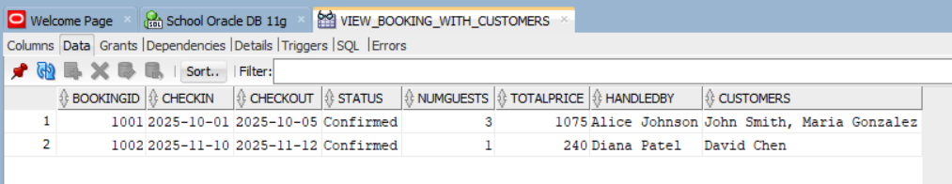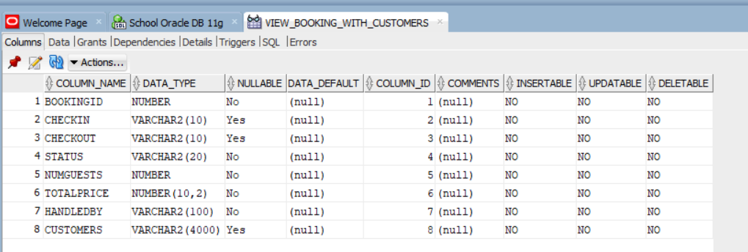

View 2

This view shows all active customers. Meaning customers that have a booking associated with them.

It joins the Customer table with the Booking_Customer table.

It also uses the DISTINCT keyword, so that if a customer is associated with more than one booking, they will NOT show multiple times in different rows. Rather, they will just show up once.

CREATE OR REPLACE VIEW VIEW_ACTIVE_CUSTOMERS AS
SELECT DISTINCT
c.CustomerID,
c.CusName,
c.Email
FROM Customer c
JOIN Booking_Customer bc
ON bc.CustomerID = c.CustomerID;

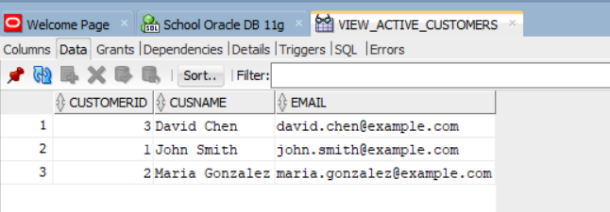
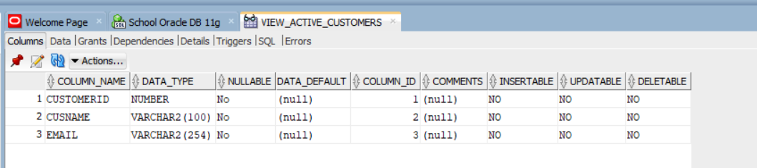
View 3

This view shows which services add ons are associated with a booking, and which customers for which the service is for.

CREATE OR REPLACE VIEW VIEW_BOOKING_SERVICES AS
SELECT
b.BookingID,
TO_CHAR(b.CheckIn,'YYYY-MM-DD') AS CheckIn,
TO_CHAR(b.CheckOut, 'YYYY-MM-DD') AS CheckOut,
e.EmpName AS EmployeeName,
c.CusName AS CustomerName,
s.ServiceName,
sb.Quantity,
FROM Booking b
JOIN Employee e ON e.EmployeeID = b.EmployeeID
JOIN Booking_Customer bc ON bc.BookingID = b.BookingID
JOIN Customer c ON c.CustomerID = bc.CustomerID
JOIN Service_Booking sb ON sb.BookingID = b.BookingID
JOIN Service s ON s.ServiceID = sb.ServiceID;

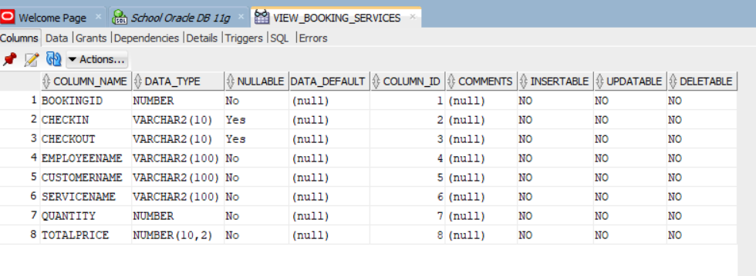
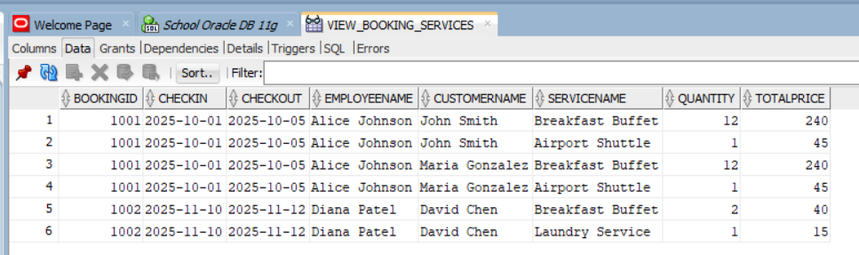

Queries

Query 1
Show all customers:
CustomerID
CusName
Email
Order by their CusName, alphabetical order

SELECT CustomerID, CusName, Email
FROM Customer
ORDER BY CusName;
- ΠCustomerID, CusName, Email​(Customer)

Query 2

Show all customers who have an IDTYPE = ‘Passport’
Show these columns:
CustomerID
CusName
IdType

SELECT CustomerID, CusName, IDType
FROM Customer
WHERE IDType = 'Passport';
- ΠCustomerID, CusName, IDType​(σIDType=′Passport′​(Customer))
Query 3

Show all Rooms that have their status column = ‘Available’
Order these rooms by Price in ascending order
Show these columns:
RoomNum, RoomTypeName, Price

SELECT r.RoomNum, rt.RoomTypeName, r.Price
FROM Room r
JOIN Room_Type rt
ON r.RoomType = rt.RoomTypeID
WHERE r.Status = 'Available'
ORDER BY r.Price;

- ΠRoomNum, RoomTypeName, Price​(σStatus=′Available′​(Room ⋈Room.RoomType=Room_Type.RoomTypeID​ Room_Type))
Query 4

Show the Rooms where the Price is greater than 150
Show these columns:
RoomNum
Floor
RoomType
Price
Order by price in descending order

SELECT RoomNum, Floor, RoomType, Price
FROM Room
WHERE Price > 150
ORDER BY Price DESC;
- ΠRoomNum, Floor, RoomType, Price​(σPrice>150​(Room))

Query 5

Show all Employees whose salary is less than 50000 and order by ascending Salary
Show these columns:
EmployeeID
EmpName
EmpRole
Salary

SELECT EmployeeID, EmpName, EmpRole, Salary
FROM Employee
WHERE Salary < 50000
ORDER BY Salary;
- ΠEmployeeID, EmpName, EmpRole, Salary​(σSalary<50000​(Employee))

Query 6

Show all Bookings that have a status of ‘Confirmed’
Show these columns:
BookingID, CheckIn, CheckOut, Status

SELECT BookingID, CheckIn, CheckOut, Status
FROM Booking
WHERE Status = 'Confirmed';
- ΠBookingID, CheckIn, CheckOut, Status​(σStatus=′Confirmed′​(Booking))

Query 7

Show all Bookings that have a status of ‘Cancelled’
Show these columns:
BookingID
CheckIn
CheckOut
Status

SELECT BookingID, CheckIn, CheckOut, Status
FROM Booking
WHERE Status = 'Cancelled';
- ΠBookingID, CheckIn, CheckOut, Status​(σStatus=′Cancelled′​(Booking))

Query 8

Show Bookings and join the Employee table with the Booking table, so that we can show the name of the employee that handled a Booking.

SELECT b.BookingID, b.Status, e.EmpName AS HandledBy
FROM Booking b
JOIN Employee e
ON b.EmployeeID = e.EmployeeID
ORDER BY b.BookingID;
- ΠBookingID, Status, EmpName​(Booking ⋈Booking.EmployeeID=Employee.EmployeeID​ Employee)

Query 9

Show bookings and the associated Customer Names

SELECT b.BookingID, c.CusName
FROM Booking b
JOIN Booking_Customer bc
ON b.BookingID = bc.BookingID
JOIN Customer c
ON c.CustomerID = bc.CustomerID
ORDER BY b.BookingID, c.CusName;
- ΠBookingID, CusName​((Booking ⋈Booking.BookingID=Booking_Customer.BookingID​ Booking_Customer) ⋈Booking_Customer.CustomerID=Customer.CustomerID​ Customer)

Query 10

Show Employees and the Customers they served.

SELECT DISTINCT e.EmpName, c.CusName
FROM Employee e
JOIN Booking b
ON e.EmployeeID = b.EmployeeID
JOIN Booking_Customer bc
ON bc.BookingID = b.BookingID
JOIN Customer c
ON c.CustomerID = bc.CustomerID
ORDER BY e.EmpName, c.CusName;
- ΠEmpName, CusName​(Employee ⋈Employee.EmployeeID=Booking.EmployeeID​ Booking ⋈Booking.BookingID=Booking_Customer.BookingID​ Booking_Customer ⋈Booking_Customer.CustomerID=Customer.CustomerID​ Customer)

Advanced Join Queries (similar to Q9 & Q10)

Similar to Q9

SELECT BOOKINGID, STATUS, NUMGUESTS, TOTALPRICE, e.EMPNAME, b.EMPLOYEEID
FROM BOOKING b, EMPLOYEE e
WHERE b.EMPLOYEEID = e.EMPLOYEEID
ORDER BY e.EMPLOYEEID;
- ΠBookingID, Status, NumGuests, TotalPrice, EmpName, EmployeeID​(BOOKING ⋈BOOKING.EmployeeID=EMPLOYEE.EmployeeID​ EMPLOYEE)

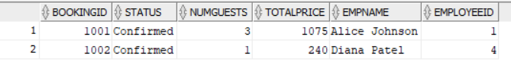

Similar to Q10

SELECT DISTINCT b.BOOKINGID, c.CUSNAME, b.TOTALPRICE
FROM BOOKING b, BOOKING_CUSTOMER bc, BOOKING_ROOM br, CUSTOMER c
WHERE b.BOOKINGID = bc.BOOKINGID
AND b.BOOKINGID = br.BOOKINGID
AND bc.CUSTOMERID = c.CUSTOMERID
ORDER BY b.BOOKINGID;
- ΠBookingID, CusName, TotalPrice​(((BOOKING ⋈BOOKING.BookingID=BOOKING_CUSTOMER.BookingID​ BOOKING_CUSTOMER) ⋈BOOKING.BookingID=BOOKING_ROOM.BookingID​ BOOKING_ROOM) ⋈BOOKING_CUSTOMER.CustomerID=CUSTOMER.CustomerID​ CUSTOMER)

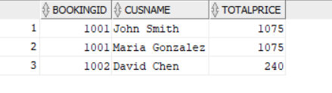

Assignment 5
Assignment 5: Week of Oct 20
Demonstration of Advanced Queries by Unix shell Implementation: For Assignment 5, hand-in the snapshots of advanced query results. Prepare at least 5 interesting advanced queries similar to the queries 9 to 23 of the lecture notes including join and set operations, statistical and aggregation functions, and grouping queries. All queries should have clear and nice formatted results.

Queries like Q11 - Q23
Query 1
CUSTOMERs that have not made any BOOKINGs

SELECT C.CUSTOMERID, C.CUSNAME
FROM CUSTOMER C
WHERE
NOT EXISTS (
SELECT 1
FROM BOOKING_CUSTOMER BC
WHERE C.CUSTOMERID = BC.CUSTOMERID
);
- ΠCustomerID, CusName​(Customer) − πCustomerID, CusName​(Customer ⋈Customer.CustomerID=Booking_Customer.CustomerID​ Booking_Customer)

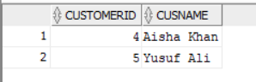

Query 2
EMPLOYEEs that have no associated BOOKING OR BOOKINGs with a TOTALPRICE < 300.

SELECT E.EMPLOYEEID, E.EMPNAME
FROM EMPLOYEE E
WHERE NOT EXISTS (
SELECT 1 FROM BOOKING B WHERE E.EMPLOYEEID = B.EMPLOYEEID
)
UNION
SELECT E.EMPLOYEEID, E.EMPNAME
FROM EMPLOYEE E
WHERE EXISTS (SELECT 1 FROM BOOKING B WHERE B.EMPLOYEEID = E.EMPLOYEEID)
AND EXISTS (SELECT 1 FROM BOOKING B WHERE B.EMPLOYEEID = E.EMPLOYEEID
AND B.TOTALPRICE < 300);
- A = ΠEmployeeID, EmpName​(Employee)−πEmployeeID, EmpName​(Employee ⋈Employee.EmployeeID=Booking.EmployeeID​ Booking)
  - EMPLOYEEs with no BOOKINGs
- E1​ = ΠEmployeeID, EmpName​(Employee ⋈Employee.EmployeeID=Booking.EmployeeID​ Booking)
  - EMPLOYEEs with BOOKINGs
- E2​ = ΠEmployeeID, EmpName​(Employee ⋈Employee.EmployeeID=Booking.EmployeeID​ σTotalPrice<300​(Booking))
  - EMPLOYEEs with BOOKINGs with TotalPrice < 300
- B = E1​ ∩ E2
- FINAL RA:
  - A ∪ B

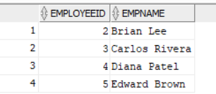

Query 3
For each BOOKING, how many unique SERVICEs were used. Only count BOOKINGs whose # of SERVICEs is >= 2.

SELECT SB.BOOKINGID, COUNT(DISTINCT SB.SERVICEID) AS NUMSERVICES
FROM SERVICE_BOOKING SB
GROUP BY SB.BOOKINGID
HAVING COUNT(DISTINCT SB.ServiceID) >= 2
ORDER BY SB.BOOKINGID;

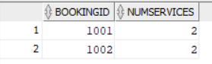

Query 4
Calculate the total QUANTITY of a SERVICE across all BOOKINGs.

SELECT S.SERVICEID, S.SERVICENAME, SUM(SB.QUANTITY) AS TOTALQUANTITY
FROM SERVICE S , SERVICE_BOOKING SB
WHERE S.SERVICEID = SB.SERVICEID
GROUP BY S.SERVICEID, S.SERVICENAME
ORDER BY TOTALQUANTITY DESC;

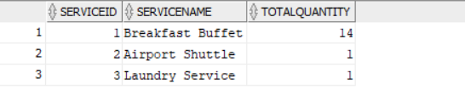

Query 5
Find all EMPLOYEEs who are associated with a BOOKING, but exclude EMPLOYEEs who earn a SALARY of at least 50000.

SELECT E.EMPLOYEEID, E.EMPNAME
FROM EMPLOYEE E, BOOKING B
WHERE E.EMPLOYEEID = B.EMPLOYEEID
MINUS
SELECT E.EMPLOYEEID, E.EMPNAME
FROM EMPLOYEE E
WHERE E.SALARY >= 50000;
- E1 = ΠEmployeeID, EmpName​(Employee ⋈Employee.EmployeeID=Booking.EmployeeID​ Booking)
- E2 = ΠEmployeeID, EmpName​(σSalary≥50000​(Employee))
- FINAL RA:
  - E1 - E2
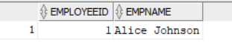

Assignment 6 - 8
Assignment 6: Week of Oct 27 Normalization of the database/ Functional Dependencies: During assignments 6, 7 and 8 you should normalize all tables to be in 3NF or BCNF. Then you should create dummy data, test and validate your application and try to optimize it. For assignment 6 you should only show Functional dependencies

Assignment 7: Week of Nov. 3 Normalization / 3NF: For assignment 7 verify all tables being in 3NF. You can use diagram (shown in the class) or explain why your tables are 3NF. If there is any table which is not in 3NF (normalized), decompose it to 3NF tables. There will be bonus mark if you use an algorithm for making a 3NF table.

Assignment 8: Week Nov. 10
Normalization/ BCNF: For assignment 8 verify all tables to see whether or not they are BCNF as shown in class. You can explain why each table is BCNF by showing FDs. If you use an algorithm for making a BCNF table as shown in class, there will be 0.5 bonus marks. Note that during assignments 7 and 8 if you change any table to make it 3NF or BCNF, again you should add data in the modified tables.

Assignment 6

PREVIOUS Tables & Keys & Dependencies Before Changes

BOOKING

Keys:
- PK = {BOOKINGID}
- FK = (EMPLOYEEID is a FK to EMPLOYEE)

Functional Dependencies:
- {BOOKINGID} → {EMPLOYEEID, NUMGUESTS, CHECKIN, CHECKOUT, STATUS, TOTALPRICE}

BOOKING_CUSTOMER

Keys:
- PK = {BOOKINGID, CUSTOMERID}

Functional Dependencies:
- There are none because there are no non-key attributes

BOOKING_ROOM

Keys:
- PK = {BOOKINGID, ROOMID}

Functional Dependencies:
- There are none because there are no non-key attributes

CUSTOMER

Keys:
- Primary key = {CUSTOMERID}
- Candidate keys = {PHONENUM}, {EMAIL}, {PHONENUM, EMAIL}

Functional Dependencies:
- {CUSTOMERID} → {CUSNAME, PHONENUM, EMAIL, IDTYPE}
- {PHONENUM} → {CUSTOMERID, CUSNAME, EMAIL, IDTYPE}
- {EMAIL} → {CUSTOMERID, CUSNAME, PHONENUM, IDTYPE}
- {PHONENUM, EMAIL} → {CUSTOMERID, CUSNAME, IDTYPE}

EMPLOYEE

Keys:
- Primary key = {EMPLOYEEID}
- Candidate keys = {PHONENUM}, {EMAIL}, {PHONENUM, EMAIL}

Functional Dependencies:
- {EMPLOYEEID} → {EMPNAME, EMPROLE, PHONENUM, EMAIL, SALARY}
- {PHONENUM} → {EMPLOYEEID, EMPNAME, EMPROLE, EMAIL, SALARY}
- {EMAIL} → {EMPLOYEEID, EMPNAME, EMPROLE, PHONENUM, SALARY}
- {PHONENUM, EMAIL} → {EMPLOYEEID, EMPNAME, EMPROLE, SALARY}

PAYMENT

Keys:
- PK = {PAYMENTID}
- FK = {BOOKINGID is a FK to BOOKING}
Functional Dependencies:
- {PAYMENTID} → {BOOKINGID, METHOD, PAYMENTDATE, AMOUNT}

ROOM

Keys:
- PK = {ROOMID}
- Candidate Key = {ROOMNUM}

Functional Dependencies:
- {ROOMID} → {ROOMNUM, FLOOR, ROOMTYPE, MAXCAP, PRICE, STATUS}
- {ROOMNUM} → {ROOMID, FLOOR, ROOMTYPE, MAXCAP, PRICE, STATUS}
- {ROOMTYPE} → {MAXCAP}

SERVICE

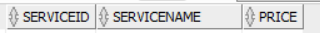
‘
Keys:
- PK = {SERVICEID}
- Candidate Keys = {SERVICENAME}

Functional Dependencies:
- {SERVICEID} → {SERVICENAME, PRICE
- {SERVICENAME} → {SERVICEID, PRICE}

SERVICE_BOOKING

Keys:
- PK = {BOOKINGID, SERVICEID}

Functional Dependencies:
- {BOOKINGID, SERVICEID} → {QUANTITY, TOTALPRICE}
- {SERVICEID} → {PRICE} (in SERVICE)
- {QUANTITY, PRICE} → {TOTALPRICE} (business rule: total = qty × unit price)

Transitive Functional Dependency in ROOM Table

ROOM(RoomID, RoomNum, Floor, RoomType, MaxCap, Price, Status)

Keys:
- PK = {ROOMID}
- Candidate Key = {ROOMNUM}

Functional Dependencies:
- {ROOMID} → {ROOMNUM, FLOOR, ROOMTYPE, MAXCAP, PRICE, STATUS}
- {ROOMNUM} → {ROOMID, FLOOR, ROOMTYPE, MAXCAP, PRICE, STATUS}
- {ROOMTYPE} → {MAXCAP}

Explanation:

- RoomID determines RoomType, and RoomType determines MaxCap.
- Therefore, RoomID → RoomType → MaxCap is a transitive dependency, because MaxCap depends on RoomType, which is not a key.
- This means that MaxCap is indirectly dependent on RoomID through another non-key attribute (RoomType).

Decomposition to Remove Transitive Dependency:

- Split the table into two relations:
  - ROOM_TYPE(RoomType, MaxCap)
  - ROOM(RoomID, RoomNum, Floor, RoomType, Price, Status)
- New Functional Dependencies:
  - In ROOM_TYPE
    - RoomType → MaxCap
  - In ROOM
    - {RoomID} → {RoomNum, Floor, RoomType, Price, Status}
- Explanation:
  - Now every non-key attribute is fully dependent on its table’s key
  - There are no non-key attributes that have a dependency with another non-key attribute
  - The transitive dependency is removed
  - Both ROOM and ROOM_TYPE are now in 3NF

Assignment 7

UPDATED Tables & Keys & IDENTIFIED Transitive Dependencies

Transitive Functional Dependency in SERVICE_BOOKING Table

SERVICE_BOOKING(BOOKINGID, SERVICEID, QUANTITY, TOTALPRICE)

Keys:
- PK = {BOOKINGID, SERVICEID}

Functional Dependencies:
- {BOOKINGID, SERVICEID} → {QUANTITY, TOTALPRICE}
- {SERVICEID} → {PRICE} (in SERVICE)
- {QUANTITY, PRICE} → {TOTALPRICE} (business rule: total = qty × unit price)

Explanation:

- PRICE is not stored in SERVICE_BOOKING; it lives in SERVICE(SERVICEID, SERVICENAME, PRICE).
- Because SERVICEID → PRICE (part of the composite key), and TOTALPRICE is a function of {QUANTITY, PRICE}, the value of TOTALPRICE depends partly on SERVICEID (a proper subset of the key) via PRICE.
- This is a partial dependency on the composite primary key, which violates 2NF (and thus 3NF).

Fix:

- Keep the price in SERVICE only.
- Remove TOTALPRICE from SERVICE_BOOKING (treat it as a derived attribute that will show up in a view).
- New relation:
  - SERVICE_BOOKING(BOOKINGID, SERVICEID, QUANTITY)
    - PK = {BOOKINGID, SERVICEID}
- Explanation:
  - Now the only non-key attribute is QUANTITY
    - It is fully dependent on the key {BOOKINGID, SERVICEID} and nothing else.
  - No partial or transitive dependencies remain → SERVICE_BOOKING is in 3NF

Other Tables:
- BOOKING, PAYMENT, CUSTOMER and EMPLOYEE, SERVICE, :
  - Each has a single-attribute PK (BOOKINGID, PAYMENTID, CUSTOMERID, EMPLOYEEID, SERVICEID) that determines all other attributes; there are no non-key→non-key dependencies
- BOOKING_CUSTOMER and BOOKING_ROOM:
  - Junction tables with composite PKs and no non-key attributes, so no partial/transitive dependencies
- ROOM and SERVICE_BOOKING
  - Handled above

Assignment 8

FINAL Tables & Keys & Dependencies

BOOKING

Keys:
- PK = {BOOKINGID}
- FK = (EMPLOYEEID is a FK to EMPLOYEE)

Functional Dependencies:
- {BOOKINGID} → {EMPLOYEEID, NUMGUESTS, CHECKIN, CHECKOUT, STATUS, TOTALPRICE}

BOOKING_CUSTOMER

Keys:
- PK = {BOOKINGID, CUSTOMERID}

Functional Dependencies:
- There are none because there are no non-key attributes

BOOKING_ROOM

Keys:
- PK = {BOOKINGID, ROOMID}

Functional Dependencies:
- There are none because there are no non-key attributes

CUSTOMER

Keys:
- Primary key = {CUSTOMERID}
- Candidate keys = {PHONENUM}, {EMAIL}, {PHONENUM, EMAIL}

Functional Dependencies:
- {CUSTOMERID} → {CUSNAME, PHONENUM, EMAIL, IDTYPE}
- {PHONENUM} → {CUSTOMERID, CUSNAME, EMAIL, IDTYPE}
- {EMAIL} → {CUSTOMERID, CUSNAME, PHONENUM, IDTYPE}
- {PHONENUM, EMAIL} → {CUSTOMERID, CUSNAME, IDTYPE}

EMPLOYEE

Keys:
- Primary key = {EMPLOYEEID}
- Candidate keys = {PHONENUM}, {EMAIL}, {PHONENUM, EMAIL}

Functional Dependencies:
- {EMPLOYEEID} → {EMPNAME, EMPROLE, PHONENUM, EMAIL, SALARY}
- {PHONENUM} → {EMPLOYEEID, EMPNAME, EMPROLE, EMAIL, SALARY}
- {EMAIL} → {EMPLOYEEID, EMPNAME, EMPROLE, PHONENUM, SALARY}
- {PHONENUM, EMAIL} → {EMPLOYEEID, EMPNAME, EMPROLE, SALARY}

PAYMENT

Keys:
- PK = {PAYMENTID}
- FK = {BOOKINGID is a FK to BOOKING}
Functional Dependencies:
- {PAYMENTID} → {BOOKINGID, METHOD, PAYMENTDATE, AMOUNT}

ROOM

Keys:
- PK = {ROOMID}
- Candidate Key = {ROOMNUM}
- FK = (ROOMTYPE is a FK to ROOM_TYPE)

Functional Dependencies:
- {ROOMID} → {ROOMNUM, FLOOR, ROOMTYPE, PRICE, STATUS}
- {ROOMNUM} → {ROOMID, FLOOR, ROOMTYPE, PRICE, STATUS}

ROOM_TYPE

Keys:
- PK = {ROOMTYPEID}
- Candidate Key = {ROOMTYPENAME}

Functional Dependencies:
- {ROOMTYPEID} → {ROOMTYPENAME, MAXCAPACITY}
- {ROOMTYPENAME} → {ROOMTYPEID, MAXCAPACITY}

SERVICE

‘
Keys:
- PK = {SERVICEID}
- Candidate Keys = {SERVICENAME}

Functional Dependencies:
- {SERVICEID} → {SERVICENAME, PRICE
- {SERVICENAME} → {SERVICEID, PRICE}

SERVICE_BOOKING

Keys:
- PK = {BOOKINGID, SERVICEID}

Functional Dependencies:
- {BOOKINGID, SERVICEID} → {QUANTITY}

BCNF Verification

Tables | BCNF Check | Explanation
Customer | Yes | All FDs have a candidate key (CustomerID or (PhoneNum,Email)) on the left hand side.
Room | Yes | Each FD determinant (RoomID or RoomNum) is a candidate key.
Room_Type | Yes | Each FD determinant (RoomTypeID or RoomTypeName) is a candidate key.
Employee | Yes | The left hand side are candidate keys (EmployeeID or (PhoneNum,Email)).
Service | Yes | The left hand side are candidate keys (ServiceID or ServiceName).
Booking | Yes | The left hand side in this case, (BookingID) is the key.
Booking_Room | Yes | The composite key (BookingID, RoomID) determines all attributes.
Booking_Customer | Yes | The composite key (BookingID, CustomerID) determines all attributes.
Payment | Yes | PaymentID uniquely determines other attributes. BookingID is also unique (1:1).
Service_Booking | Yes | Composite key (BookingID, ServiceID) determines all attributes.

Assignment 9
Assignment 9: Week of Nov 17(Project Demo)
Demonstration of application using Java/web based UI and Individual Evaluation of the Project: The DB application should be in 3NF/BCNF and contain dummy records and brief comments in the code about any special cases and advanced reports. There will be 3 extra bonus marks for creating either JAVA (or Python) UI or web application implementation. You can make web applications by Oracle Express or any other method connecting to Oracle DB on your laptop or school DB. There is a separate
section for showing the bonus mark of assignment 9 which can be shown and submitted during the lab for assignment 10 as well.

Compilation & Menu
Upon initially running the application:
- The user is given various options on how they want to manipulate the database.
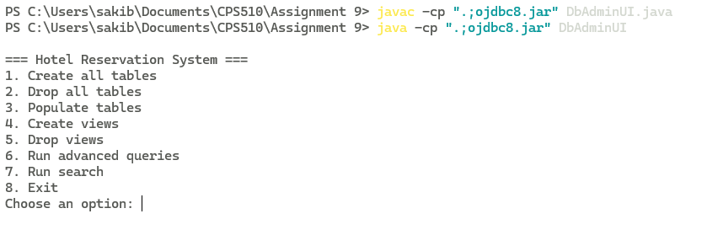
- Initially, the database is empty, so all options besides “1. Create all tables” will result in error.
- Example below:
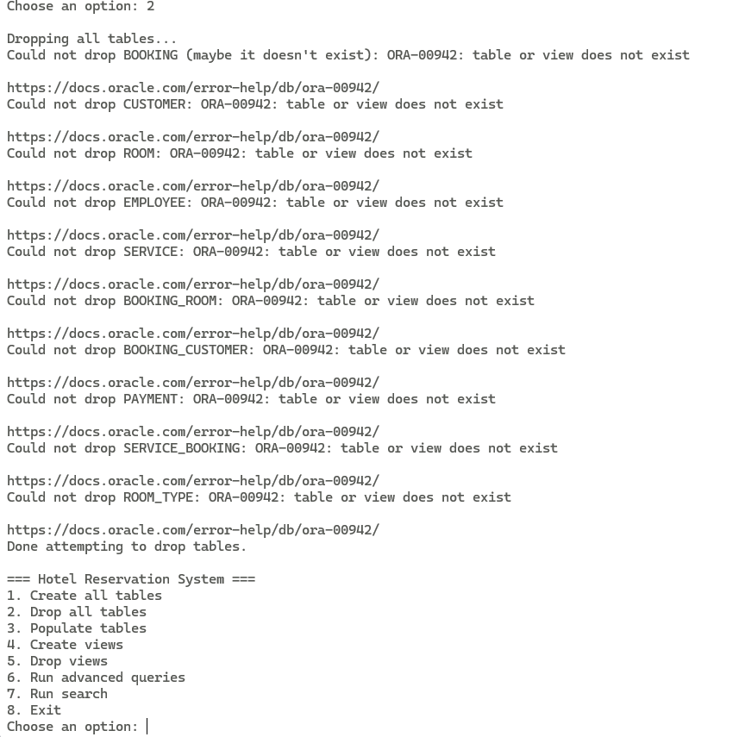

Create Tables
This option creates all the tables required for the DB. All tables are in 3NF & BCNF.
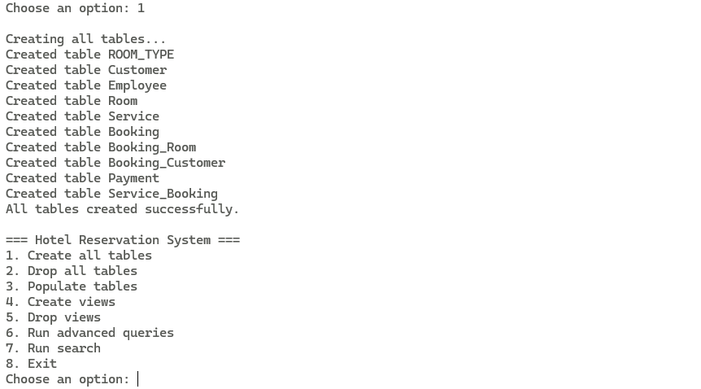

Create Views
This option creates all the views required for this DB.
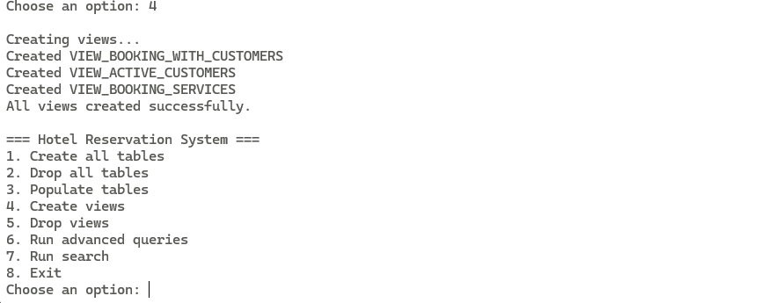

Populate Tables
This option populates the tables with dummy data.

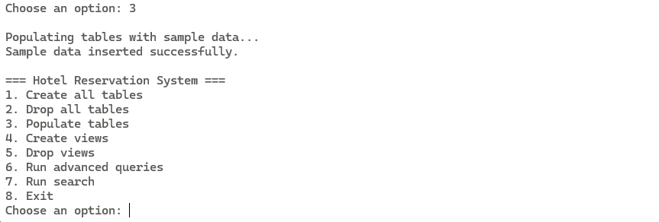Advanced Queries Menu
This option opens the “Advanced Queries Menu” allowing for various detailed queries on the DB.
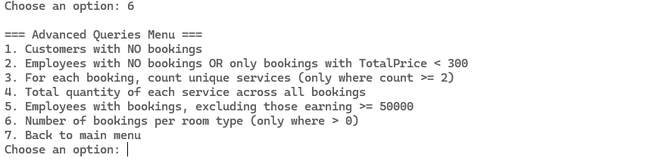

Advanced Query Example
This is an example run of the 4th query which will display the results of the quantity of how many times each Service is used.

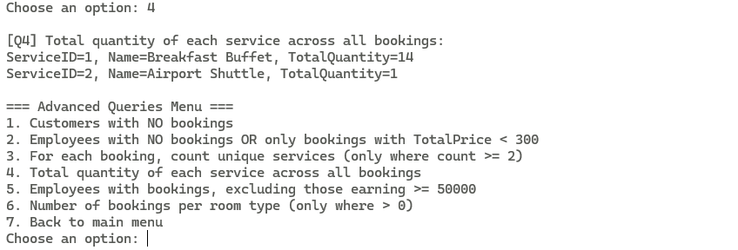

Back to Main Menu
This option takes the user back to the initial menu, a.k.a. The Main Menu.
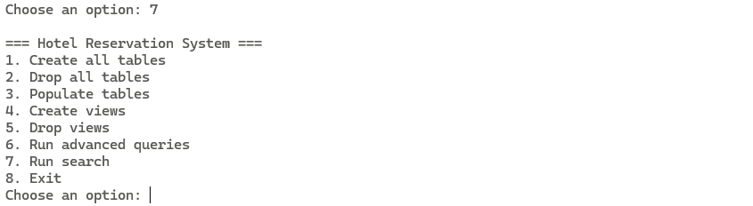

Search Menu
This option pulls up the Search Menu that allows Users to query for specific records.
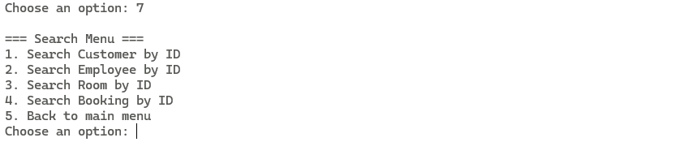

Search Example
This is an example run for the 4th search option. Upon selecting, the application will prompt the User to specify the ID of the record they want to search.
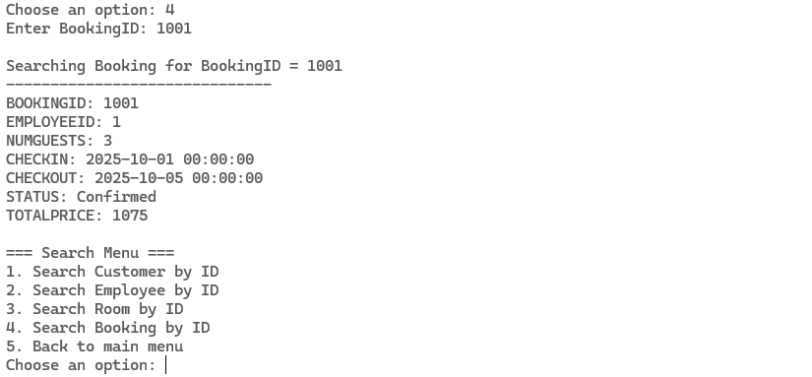
In the case of no record existing with such ID. The following will occur.
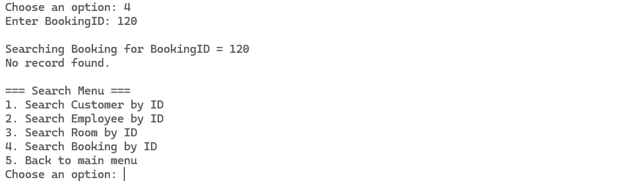

Drop Views
This option allows the User to drop all views within the DB.
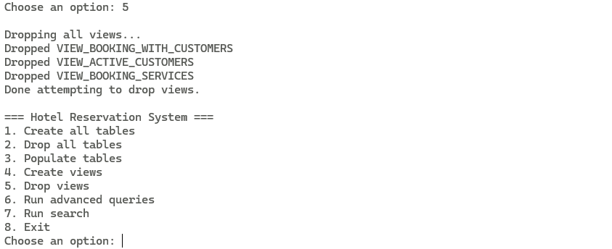

Drop Tables
This option allows the user to drop all the tables within the DB.
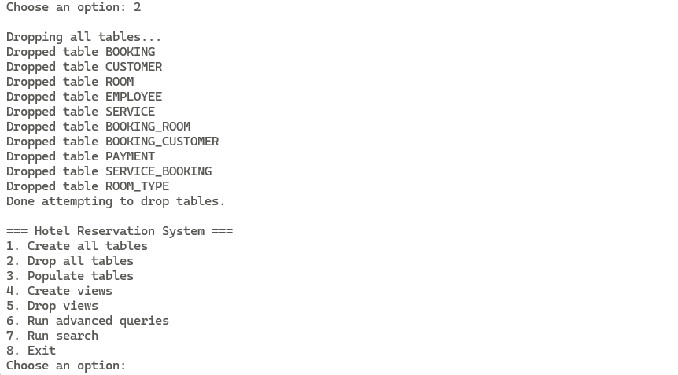

Exit
This option allows the User to exit the program.

Concluding Remarks
The completion of this project demonstrates the full design, implementation, and validation of a functional Hotel Management Database System. Across Assignments 1 to 10, we developed the conceptual model, normalized the schema to 3NF/BCNF, created and populated the database in Oracle and implemented a Java-based UI to interact with the system. We also produced and translated SQL queries into relational algebra to show a deeper understanding of the underlying mathematical foundations. Overall, this project provided a comprehensive end-to-end experience in database design, optimization, and application development in relation to a DBMS.

